ECEN5743 Final Project Proposal
Yash Trivedi

My research direction involves using visualization techniques to analyze the boiling of fluid flows and reliably identifying key characteristics of the flow: heat transfer, boiling regime, and onset of critical heat flux. Critical heat flux (CHF) is the point where heat transfer into the fluid drops, and the heated surface temperature shoots up. Therefore, it is important to operate systems beneath that point. For this project, I will attempt to use a CNN to analyze frames from boiling imaging to make a prediction how close a system is to CHF.

To achieve this, a non-dimensional CHF proximity index will be defined to characterize how close a system is to failure. Binary classification of CHF can be useful, but we believe that understanding proximity to failure is more useful for systems attempting to operate close to CHF. The proximity index will be defined as shown below, using a ratio of surface temperature superheat at a point against CHF.

$$Π_{CHF}=\frac{T_{wall}-T_{sat}}{{(T_{wall}-T_{CHF})}_{CHF}}$$

We have a database of pool boiling imaging and temperature data from another publication (Pandey et al., 2025). Videos have been filmed of the boiling, and I have already extracted individual frames which can be fed into the network, shown in Figure 1. Alongside imaging, raw temperature data is available which will help identify exactly where CHF takes place, shown in Figure 2. To assign a target for each image, the temperature superheat can be calculated at each data point and at CHF to form the non-dimensional ratio. The main factor to pay attention to is that shortage of data. Roughly 2000 frames are extracted from two long clips, making a fairly limited data set. Additionally, one of the clips may be
withheld as a test set. Therefore, consideration on the small dataset will have to be made when selecting a network.

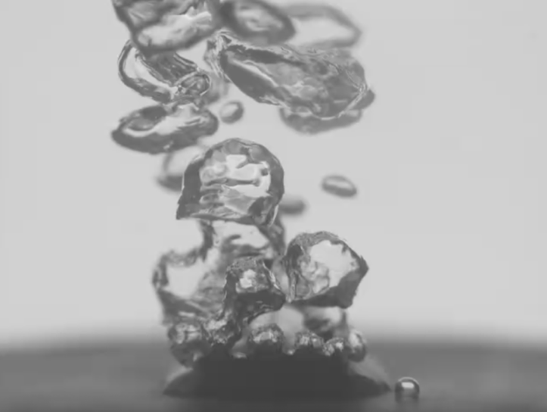
Figure 1 – Example Image from Pool Boiling Visualization Dataset

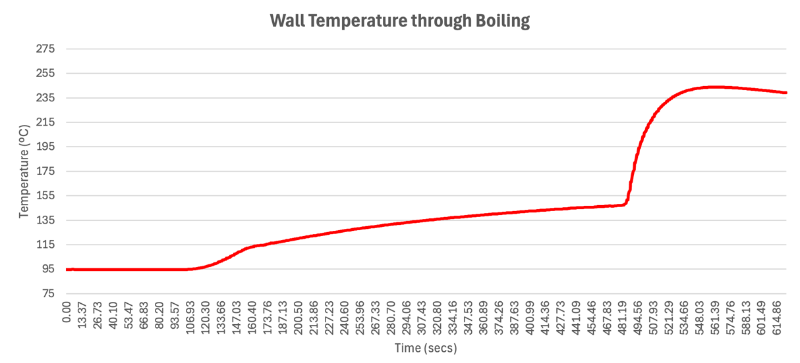
Figure 2 – Example Wall Temperature Plot
To perform this project, as mentioned before, I will use a CNN to take visual frames and create proximity index predictions. Due to small data availability, transfer learning from a pretrained model will be the preferred technique. For a pretrained model, there are several available options: ResNet-50, ConvNeXt, U-Net, etc. All of these options are common models used by teams attempting to use CNNs to make predictions, but ultimately ResNet-50 is what will be used for now. When deciding, the choice was made to go against larger and more complex models that may benefit from bigger datasets. A model that is lighter may be stronger at making a prediction on the smaller dataset without risking as much overfitting. The ResNet architecture natively acts as a classifier, so the final layer has 1000 output classes with a softmax activation function. The final layer will be replaced with a single neuron output and ReLU activation. PyTorch will be used as the framework simply because I am more familiar with the framework.
Regarding reference material, I will be using some prior research on boiling prediction using customized pre-trained CNNs to help inform my project. A lot of these papers cover methods to classify regime or to perform binary classification. I will be doing something a little different with my non-dimensional proximity index, but the prior work will be useful to refer to. For example, Paz et. al, investigated AlexNet and ResNet to classify boiling regimes (Paz et al., 2025). Regarding ResNet itself, the paper outlining the network will be used for understanding the network (He et al., 2015). Since the deep network will attempt to perform regression, the performance of the model can be judged using the mean square error performance function.

Regarding a rough schedule for this project, this initial project proposal will be submitted by March 26th. The entire project will conclude by April 28th, so milestones should be made between then. Data preparation and target labelling should be completed by April 3rd, and a first run network should be programmed by April 10th. This will allow me to spend the week till April 17th to evaluate the results of the first pass and make changes and improvements. Finally, the final presentation will be made by April 28th, and the final report will be completed by May 5th.

References:
He, K., Zhang, X., Ren, S., & Sun, J. (2015). Deep Residual Learning for Image Recognition (arXiv:1512.03385). arXiv. https://doi.org/10.48550/arXiv.1512.03385
Pandey, H., Li, C., Dunlap, C., & Hu, H. (2025). Unveiling hysteresis of transient boiling: A multimodal perspective. Applied Thermal Engineering, 262, 125259. https://doi.org/10.1016/j.applthermaleng.2024.125259
Paz, C., Cabarcos, A., Concheiro, M., & Conde-Fontenla, M. (2025). Classification of boiling regimes, fluids, and heating surfaces through deep learning algorithms and image analysis. International Journal of Heat and Mass Transfer, 242, 126829. https://doi.org/10.1016/j.ijheatmasstransfer.2025.126829

